Nunda Historical Society Trip to Buffalo – July 22, 2013

The Society is sponsoring a tour to Buffalo on Monday, July 22. After spending the morning at the Buffalo and Erie County Naval& Military Park, we lunch at Chef’s and then visit Frank Lloyd
Wright’s Darwin Martin House for a two-hour tour of this complex, a historic landmark. The Covered Wagon coach will leave at 8 AM and return by 6:30 PM. The cost of this tour is $95 for members and $105 for non-members. Not a Society member? Join today. Individual Memberships are $10 and $15 for a Family.
Reservations and payment must be made by July 1. Reservation Forms are available at: www.nundahistory.org, at the NHS Museum, or from a board member. Send to Nunda Historical Society, PO Box 341, Nunda, NY 14517. Questions? Call Sue Long, 468-3413 or Fran Ludwig, 476-2749
___________________________________________________

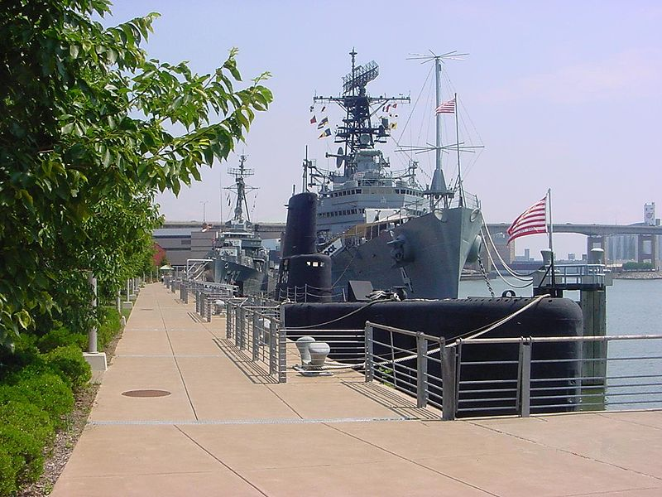
The Buffalo and Erie County Naval & Military Park is a museum on the shore of Lake Erie in Buffalo, New York. It is home to several decommissioned US Naval vessels that you will be able to tour. These are the Cleveland-class cruiser USS Little Rock, the Fletcher-class destroyer USS The Sullivans, and the submarine USS Croaker.
The construction of the Buffalo Naval and Servicemen's Park (later named the Buffalo and Erie County Naval & Military Park) started in 1977. The park was opened to the public on July 4, 1979 and has gone through a few major changes in recent years. In 2003 the ships were moved slightly to the foot of Pearl and Main streets. The Naval Park includes a new museum, abuts a historic Commercial Slip, and is part of Buffalo’s Waterfront, known as Canalside.
Along with the ships, a variety of smaller vehicles, vessels, and aircraft are also on display at the park. These include a tiny X-Ron 1 Rotorcycle one-man helicopter used by the US Marine Corps in the late fifties and early sixties, an Army M41 Walker Bulldog tank used in the Korean War, a Marine M-84 Armored personnel carrier, a Huey flown in Vietnam, an Air Force F-101 Voodoo flown by the Air National Guard's 136th FIS, Niagara Falls ARS, a Trumpy-class Fast Patrol Craft, used in Vietnam, a Navy FJ Fury (FJ-4) jet (equivalent to the Air Force's F-86 Sabre), and a P-39 Airacobra manufactured at Bell Aircraft in Buffalo which saw service in World War II.
USS Little Rock
Exhibits at the museum include: Marine Corps Memorabilia World War I to Present; Ex-POW Memorabilia; Contributions of African-Americans to Our Country's Military Heritage; Women in the Military; Polish Armed Forces; Destroyer Escort Sailors; Vietnam Veterans; Models of Military Aircraft World War II to Present; and Western New York Medal of Honor Recipients. http://www.buffalonavalpark.org

___________________________________________________

Chef’s Restaurant started in 1923, is a proud part of Buffalo’s nostalgia. In the early days Chef's had a limited menu of Spaghetti, Ravioli, Chicken and Veal Cacciatora. Lou has since expanded his menu to feature items ranging from Chef’s famous Spaghetti Parmesan to lighter items such as Pasta Broccoli.

A second dining room was added in 1966, followed by another addition three years later. Today Chef’s Restaurant dining capacity is 325, while the beautiful Lou Ann Banquet Room accommodates groups of up to 125 people. For more than 50 years Chef's has been satisfying the appetites and delighting the palates of countless lunch and dinner patrons. http://www.ilovechefs.com

___________________________________________________
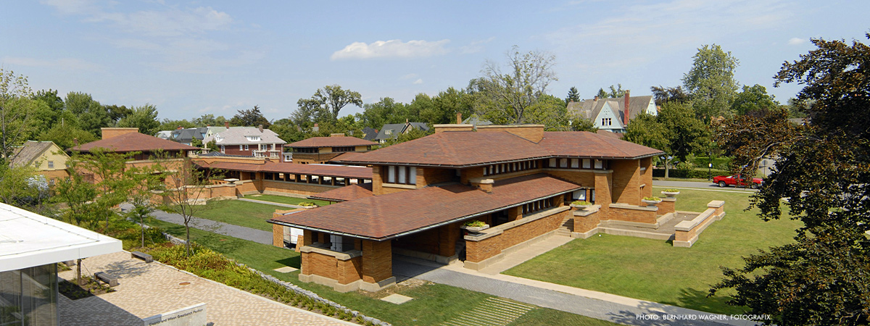
Frank Lloyd Wright (1867-1959) designed a unique residential complex for wealthy Buffalo businessman Darwin D. Martin and his family between 1903-1905. The most substantial and highly developed of Frank Lloyd Wright’s Prairie houses in the Eastern United States, The Darwin D. Martin House received National Historic Landmark status in 1986. The house is considered by leading Frank Lloyd Wright scholars as one of Wright’s finest achievements of the Prairie period and, indeed, of his entire career.
The complex consists of five interconnected buildings designed as a unified composition, including; the main Martin House and a pergola that connects it to a conservatory and carriage house with chauffeur’s quarters and stables, the Barton House, a smaller residence for Martin’s sister and brother-in-law, and a gardener’s cottage added in 1909. The landscape design for the grounds of the complex is highly integrated with the overall composition of buildings.
The Martin House is a prime example of Frank Lloyd Wright’s Prairie House ideal, with strong horizontal lines and planes, deeply overhanging eaves, a central hearth, prominent foundation, and a sheltering, cantilevered roof. The complex contains 394 examples of Frank Lloyd Wright-designed art glass, including the famed “Tree of Life” window.
Over the decades, the Martin House Complex suffered considerable damage and three of the original five buildings were demolished. In 1992, the Martin House Restoration Corporation (MHRC) was formed to raise funds for and oversee a complete restoration of the complex. Extensive reconstruction and restoration efforts began in 1997 and are ongoing today. In 2009, the MHRC opened the Eleanor and Wilson Greatbatch Pavilion, a visitor welcome and interpretive center designed by Toshiko Mori Architect. http://www.darwinmartinhouse.org

